Multiple-choice section – choose the correct answer

Question 1 [5.1]

The linear equation ** has the solution:

A  B  C  D 

Question 2 [5.2]

Rearranging the equation  gives the solution:

A ** B ** C ** D **

Question 3 [5.3]

The coordinates of the midpoint between the coordinate points  and , where *a* and *b* are constants, are:

A  B  C  D 

Question 4 [5.4]

The following table of values represents a linear relationship.

|  |  |  |  |  |
| --- | --- | --- | --- | --- |
| a | 0 | 2 | 4 | 6 |
| b | 5 | -1 | -7 | -13 |

The equation that represents this linear relationship is:

A *a* = -3*b* + 5 B *a* = 5*b* − 3 C *b* = 5*a* − 3 D *b* = -3*a* + 5

Question 5 [5.5]

Line segments *a* = (1, 5), (1, 1) and *b* = (1, 1), (4, 1) form the two sides of a triangle. The gradient of the hypotenuse of this triangle is:

A  B  C  D 

Question 6 [5.6]

A line perpendicular to the line with equation *ax* + *by* + *c* = 0, where *a*, *b*, and *c* are constants, is:

A  B  C  D 

Question 7 [5.7]

The coordinates of two points that lie on the line ** are:

A (-3, 0) and (0, -2) B (0, -2) and (3, 0) C (3, 0) and (0, 2) D (2, 0) and (0, -3)

Question 8 [5.8]

A rectangle of perimeter 19 units is bounded (enclosed) by two vertical sides of length , and by two horizontal sides of length , where *b* > 0. One of the vertical sides is on the line *x* = 2. Which line is the other vertical side on?

**A** *x* = 3 **B** *x* = 6 **C** *x* =  **D** *x* = 5

Multiple-choice results: ___ / 8

Short answer section

Question 9 4 marks [5.1]

One-quarter of the result of a number *x* subtracted from 20 is the same as one-third of the sum of *x* and 8. Write an equation and solve it to find *x*.

Question 10 6 marks [5.2]

For each of the following form an equation first and then solve it.

**(a)** A triangle has angles (2*x* + 15)°, 5*x*° and 60°. Find the size of the two unknown angles.

**(b)** A rectangle has a perimeter of 32 cm. Its length is twice its width less 5 cm. Find its dimensions.

Question 11 5 marks [5.3]

A triangle has vertices at *A*(2, 7), *B*(6, 4) and *C*(2, 4).

**(a)** Find the length of each side.

**(b)** What type of triangle is it?

**(c)** Find the midpoint of the longest side.

Question 12 4 marks [5.4]

For the equation :

(a) complete the table of values

|  |  |  |  |  |
| --- | --- | --- | --- | --- |
| P | 0 | 3 | 6 | 9 |
| T |  |  |  |  |

(b) plot the graph on the axes provided.

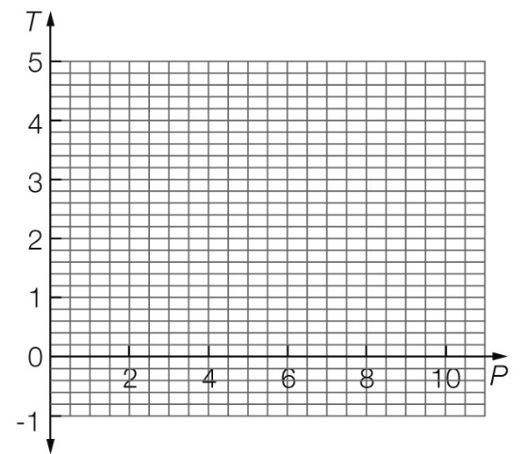

Question 13 6 marks [5.5]

Cadel rides his bicycle at a constant speed for 2 minutes, covering a distance of 1.8 km. He then rides at a new constant speed for 3 minutes, covering a distance of 2.4 km.

**(a)** Represent this information on a distance−time graph. (Put distance, in metres, on the vertical axis.) Label the two parts of your graph A and B.



**(b)** Calculate the two speeds that Cadel rides at during this journey, in m/min.

**(c)** Calculate the gradients of the two parts (A and B) of your graph.

**(d) (i)** How is speed shown on the distance–time graph?

**(ii)** In which stage of the journey is Cadel travelling at a faster speed? How is this shown on the graph?

**(e)** Calculate how much further Cadel would travel if he travels at the faster speed for the full 5 minutes.

Question 14 2 marks [5.6]

Use the *y*-intercept and gradient method to sketch the graph of 5*x −* 4*y* = 20 on the axes provided.

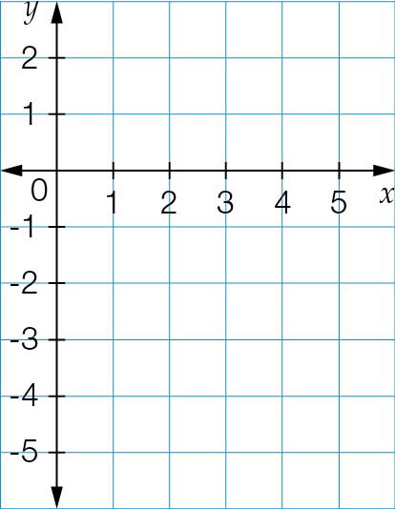

Question 15 2 marks [5.7]

Use the *x*- and *y*-intercept method to sketch the graph of = 4 on the axes provided.

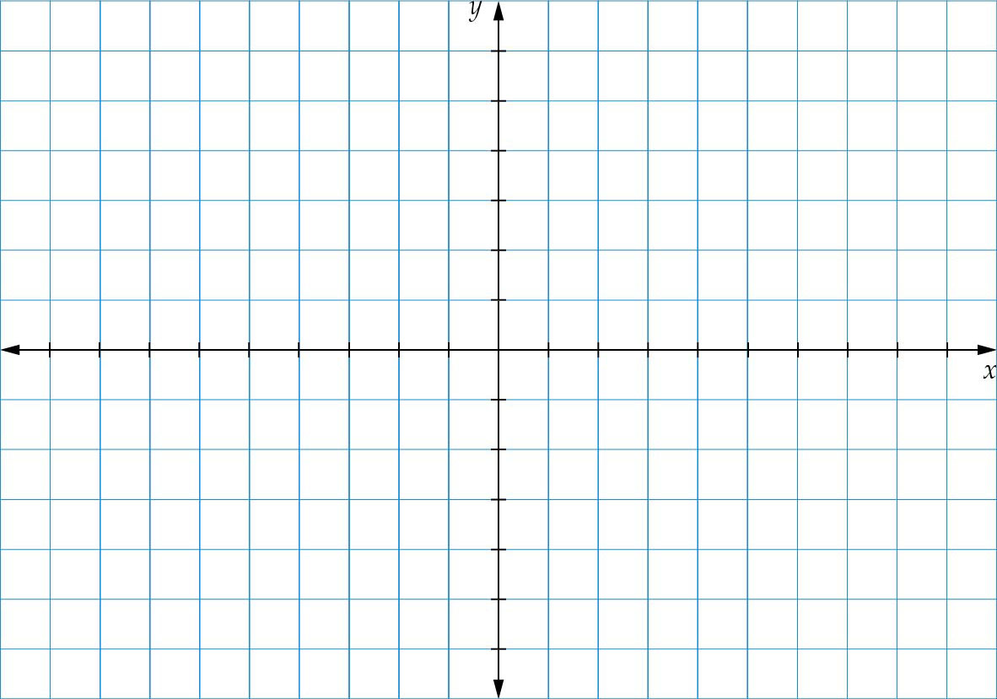

Question 16 4 marks [5.8]

Write the equation of the straight line, given the following.

**(a)** *m* = 0 and *c* = 2

**(b)** *y*-intercept = -2 and gradient = 0

**(c)** gradient = 2 and *y*-intercept = 6

**(d)** *m* = -5 and *c* = -2

Short answer results: ___ / 33

Extended answer section

Question 17 10 marks [5.3]

A quadrilateral *ABCD* has vertices at *A*(1, 9), *B*(4, 4), *C*(9, 1) and *D*(6, 6).

(a) Find the length of each side.

(b) Find the length of each diagonal.

(c) What type of quadrilateral is it?

(d) Find the midpoint of each diagonal.

(e) What do you notice about the midpoints of the diagonals?

Question 18 10 marks [5.4]

Axel, Brandon and Clarissa are taking part in a reading challenge fundraising event. They are seeking people to sponsor their reading efforts. Axel is asking for $1.50 for each book he reads. Brandon is asking for $3 plus $1 for each book he reads. Clarissa just asks for a flat $10 donation.

(a) Complete the following table of values for the three readers.

|  |  |  |  |  |  |  |  |  |  |
| --- | --- | --- | --- | --- | --- | --- | --- | --- | --- |
| Number of books/reader | 0 | 1 | 2 | 3 | 4 | 5 | 6 | 7 | 8 |
| Axel |  |  |  |  |  |  |  |  |  |
| Brandon |  |  |  |  |  |  |  |  |  |
| Clarissa |  |  |  |  |  |  |  |  |  |

(b) Use your table of values to plot a graph for each person. Label each graph with the person’s name.

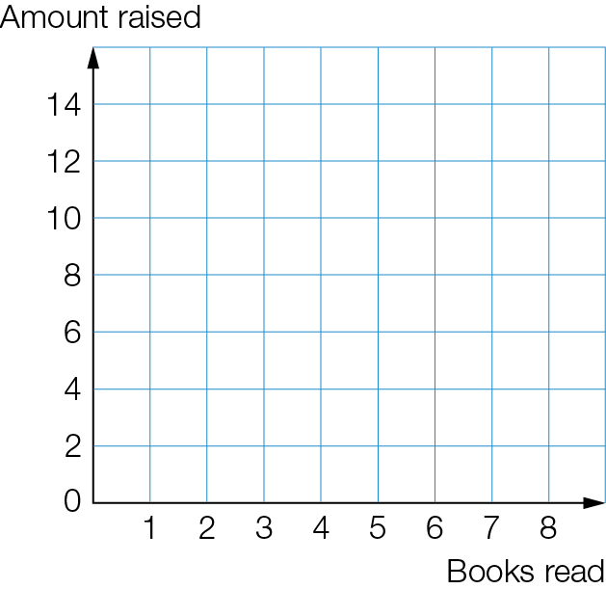

**(c)** Is there a number of books for which all collect the same amount of money? If so, what is it?

**(d)** Identify the number of books read for which:

**(i)** Axel raises the most money

**(ii)** Brandon raises the most money

**(iii)** Clarissa raises the most money.

Question 19 12 marks [5.6, 5.7, 5.8]

A surveyor is using the Cartesian plane to plot the boundaries of a piece of land. The boundaries are straight lines. The boundaries are described by the following equations: *y* =, *y* = 5,   
*y* + 6 = *x*, *y* + *x* = -8 and *x* = -6.

(a) Sketch each of the lines on the axes provided.

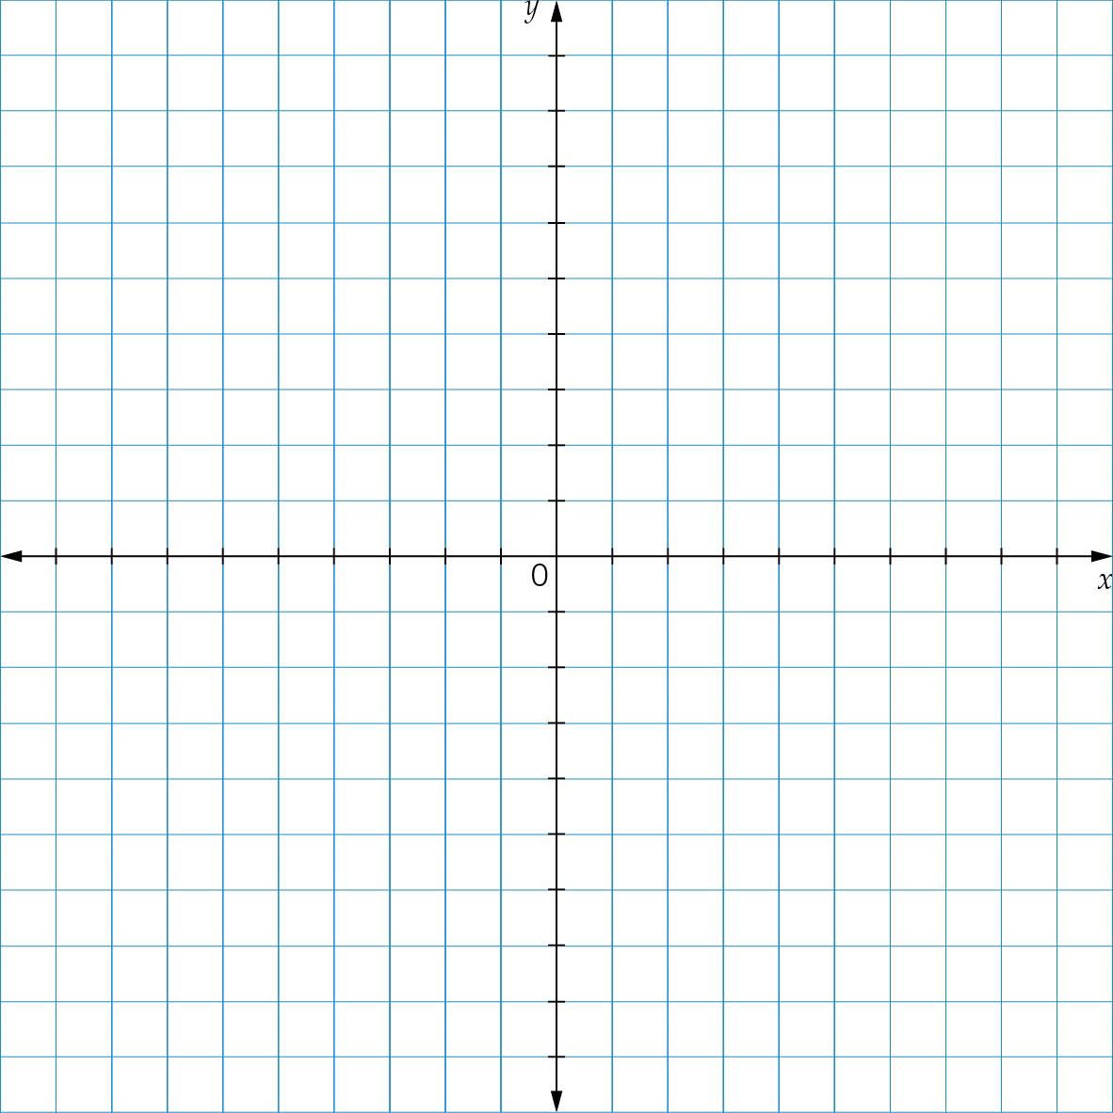

**(b)** Write the coordinates of the five ‘corners’ of the design.

**(c)** The shape is now to be divided by a line passing through the top left-hand corner and the origin. What is the equation of this line?

**(d)** A final dividing line connects the lowest corner to the origin. What is the equation of that line?

Extended answer results: ___ / 32

TOTAL test results: ___ / 73